SCHOOL

Year 12 Trial WACE Examination, 2013

Question/Answer Booklet

MATHEMATICS 2C/2D
SOLUTIONS

Section One:

Calculator-free

Student Number: In figures

In words

Your name

Time allowed for this section
Reading time before commencing work: five minutes
Working time for this section: fifty minutes

Materials required/recommended for this section

To be provided by the supervisor
This Question/Answer Booklet
Formula Sheet

To be provided by the candidate
Standard items: pens, pencils, pencil sharpener, eraser, correction fluid/tape, ruler, highlighters

Special items: nil

Important note to candidates

No other items may be used in this section of the examination. It is your responsibility to ensure that you do not have any unauthorised notes or other items of a non-personal nature in the examination room. If you have any unauthorised material with you, hand it to the supervisor before reading any further.

Structure of this paper

Section | Number of questions available | Number of questions to be answered | Working time (minutes) | Marks available | Percentage of exam
Section One:  Calculator-free | 6 | 6 | 50 | 50 | 33
Section Two:  Calculator-assumed | 12 | 12 | 100 | 100 | 67
 |  |  | Total | 150 | 100

Instructions to candidates

- The rules for the conduct of Western Australian external examinations are detailed in the Year 12 Information Handbook 2013. Sitting this examination implies that you agree to abide by these rules.

- Write your answers in the spaces provided in this Question/Answer Booklet. Spare pages are included at the end of this booklet. They can be used for planning your responses and/or as additional space if required to continue an answer.
- Planning: If you use the spare pages for planning, indicate this clearly at the top of the page.
- Continuing an answer: If you need to use the space to continue an answer, indicate in the original answer space where the answer is continued, i.e. give the page number. Fill in the number of the question(s) that you are continuing to answer at the top of the page.

- Show all your working clearly. Your working should be in sufficient detail to allow your answers to be checked readily and for marks to be awarded for reasoning. Incorrect answers given without supporting reasoning cannot be allocated any marks. For any question or part question worth more than two marks, valid working or justification is required to receive full marks. If you repeat an answer to any question, ensure that you cancel the answer you do not wish to have marked.

- It is recommended that you do not use pencil, except in diagrams.

Section One: Calculator-free (50 Marks)
This section has six (6) questions. Answer all questions. Write your answers in the spaces provided.

Working time for this section is 50 minutes.

Question 1 (10 marks)
(a) State the gradient of the line 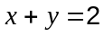. (1 mark)
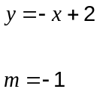

(b) Simplify 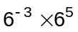, giving your answer without indices. (1 mark)
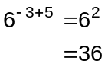

(c) Show by substitution that 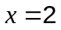 is a better solution for 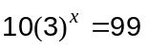 than 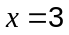. (2 marks)
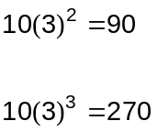

Hence is a better soln.

(d) Loan A, offers interest of 5% pa compounded every four months. Loan B, offers interest of 5% pa compounded quarterly. Which loan, if either, would generate more interest on $1000 invested for 5 years? Justify your answer. (2 marks)
Loan B.

Interest will increase faster when compounded more frequently.

(e) A student made the generalisation that all terms of the sequence defined by the rule 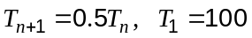 would be integers. Use a counter example to show that the statement is false. (2 marks)

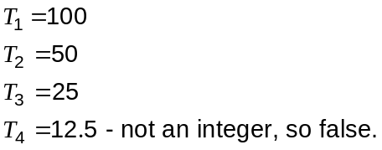

(f) Sketch the graph of 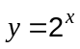 on the axes below. (2 marks)
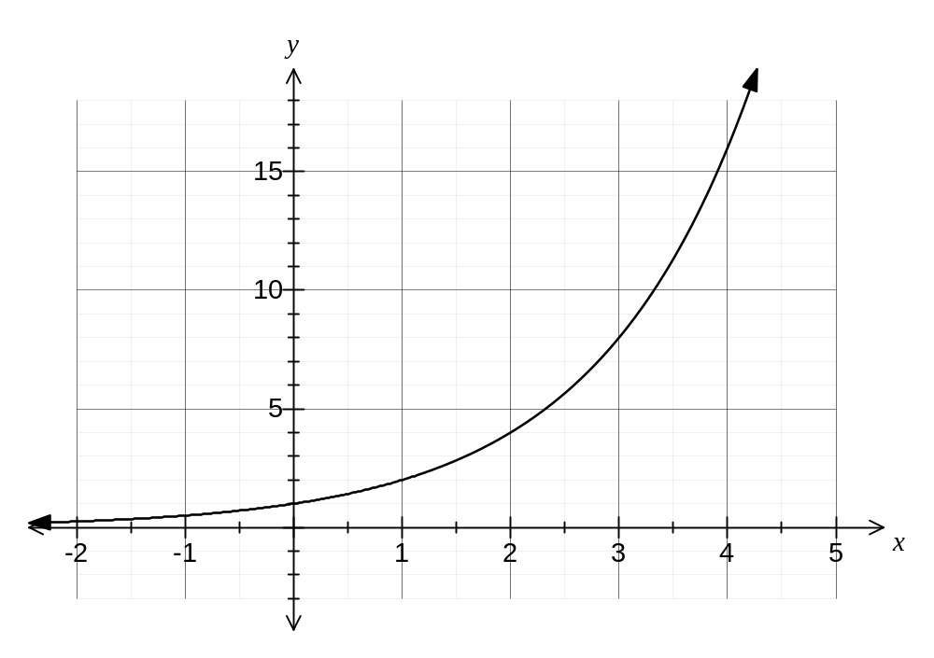

Question 2 (8 marks)
(a) Determine the coordinates of the -intercept of 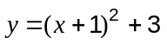. (1 mark)
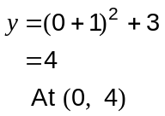

(b) State the coordinates of the turning point of 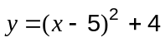. (1 mark)
(5, 4)

(c) Factorise 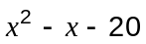. (2 marks)
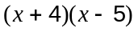

(d) Solve 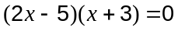. (2 marks)
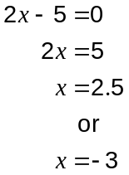

(e) Describe the effect of changing from 9 to 4 when graphing 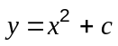. (2 marks)
Translate the graph down by 5 units

Question 3 (8 marks)
The diagram shows the points A(-1, 2), B(4, 3), C(5, 1) and D(1, -2).
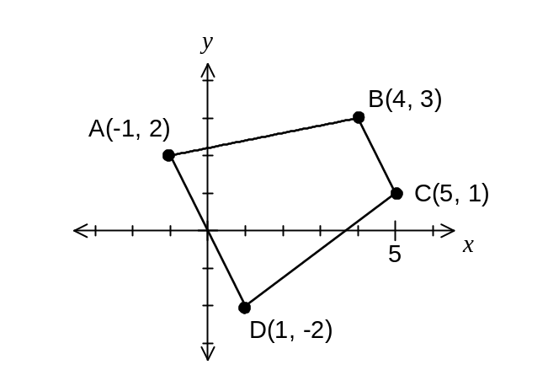
(a) Determine the gradient of the line passing through A and D. (2 marks)
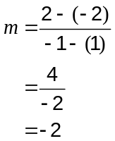

(b) The equation of the line through BC is 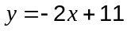. Determine the gradient of the line that is perpendicular to this line. (2 marks)
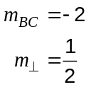

(c) Determine the equation of the line passing through B that is parallel to the line 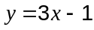.
(2 marks)
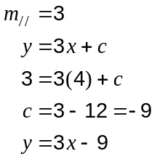

(d) Calculate the length of the line between C and D. (2 marks)
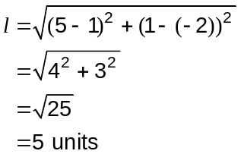

Question 4 (6 marks)
(a) If 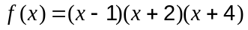, evaluate 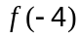. (1 mark)
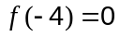

(b) Match each function in the table below with its graph. (3 marks)

Function | Graph (A, B or C)
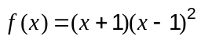 | C
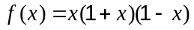 | A
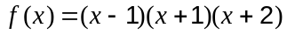 | B

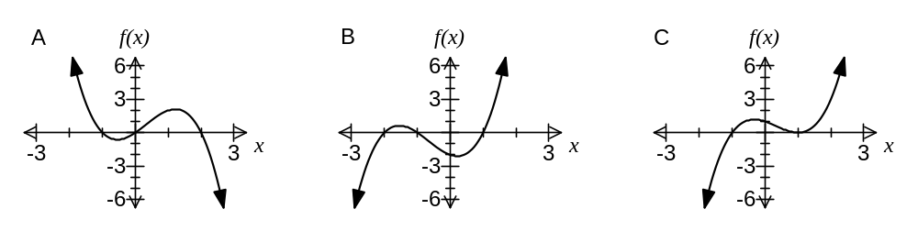

(c) The graph of 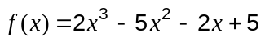 is shown below. (2 marks)
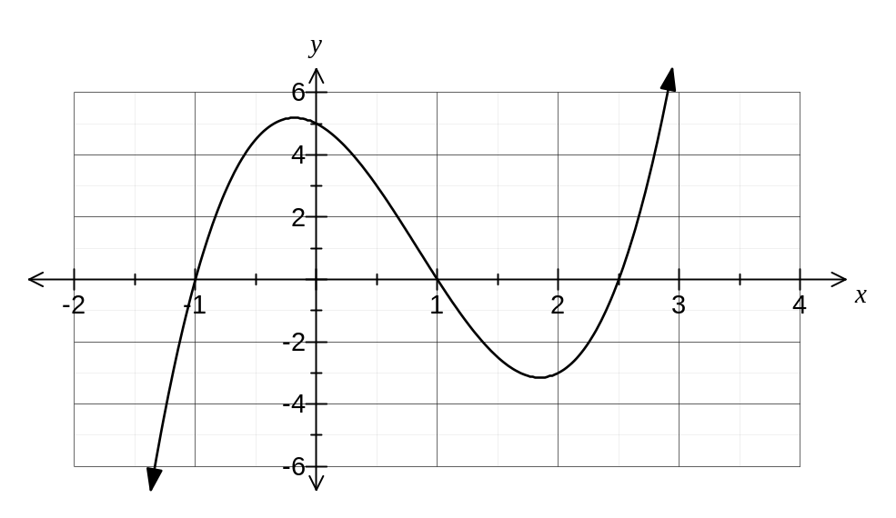
Solve 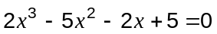.

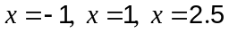

Question 5 (8 marks)
The table below shows, to the nearest dollar, the value of $1 000 invested at different interest rates for periods of up to five years with interest compounded annually.

 | Annual interest rate
Years | 1% | 2% | 3% | 4% | 5% | 6%
1 | 1 010 | 1 020 | 1 030 | 1 040 | 1 050 | 1 060
2 | 1 020 | 1 040 | 1 061 | 1 082 | 1 103 | 1 124
3 | 1 030 | 1 061 | 1 093 | 1 125 | 1 158 | 1 191
4 | 1 041 | 1 082 | 1 126 | 1 170 | 1 216 | 1 262
5 | 1 051 | 1 104 | 1 159 | 1 217 | 1 276 | 1 338

(a) State the value of $1 000 invested at 5% pa after 3 years. (1 mark)
$1 158

(b) How much interest will be earned by investing $1 000 at 2% pa for 5 years? (1 mark)
$104

(c) $216 interest was earned by investing $1 000 for 4 years. What was the annual interest rate? (1 mark)
5%

(d) How much interest will be earned by investing $20 000 at 6% pa for 2 years? (2 marks)
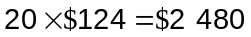

(e) If the price of a work of art is expected to increase by 4% each year and it is currently worth $10 400, what will it be worth in 3 years time? (2 marks)
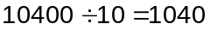
1 040 -> 1 082 -> 1 125 -> 1 170 (4% column)
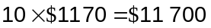

(f) The recursive rule 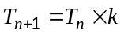, 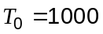, was used to calculate the figures in the column headed 5% in the table. What is the value of in this rule? (1 mark)
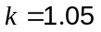

Question 6 (10 marks)
The graphs of , 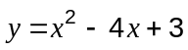 and 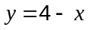 are shown on the axes below.
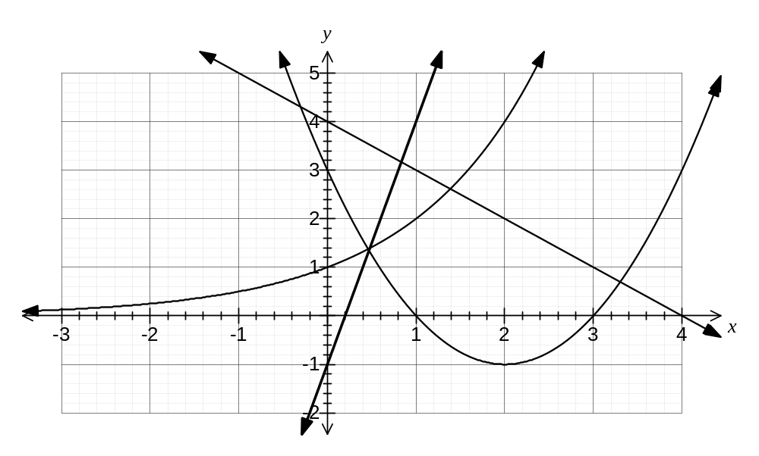
(a) Using the graph, or otherwise, solve the following equations:

(i) 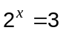 (1 mark)
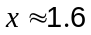

(ii) 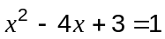 (2 marks)
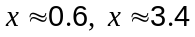

(iii) 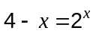 (1 mark)
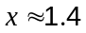

(iv) 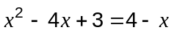 (2 marks)
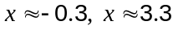

(b) Add the graph of 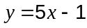 to the axes above. (2 marks)

(c) Use your graph to solve the simultaneous equations and . (2 marks)
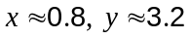

Additional working space

Question number: _________

Additional working space

Question number: _________

This examination paper may be freely copied, or communicated on an intranet, for non-commercial purposes within educational institutes that have purchased the paper from WA Examination Papers provided that WA Examination Papers is acknowledged as the copyright owner. Teachers within purchasing schools may change the paper provided that WA Examination Paper's moral rights are not infringed.

Copying or communication for any other purposes can only be done within the terms of the Copyright Act or with prior written permission of WA Examination papers.

Published by WA Examination Papers
PO Box 445 Claremont WA 6910

